Lab 07 – GUI Tips and Tricks Submission

Alberto Martinez
November 21, 2004
Problem
The problem, simply put, was collision detection. I thought it to be extremely easy and implemented a very simply method of collision detection but found it to be unstable. Here is why and how to fix it.
The game I was making is called Comboling. The game is played with a field of tiles in a 10x10 tile field. Tiles are (here is where we come in) randomly placed on the field and the object of the game is to select all of the tiles. After the first tile, the user can select tiles vertical, horizontal and diagonal of the currently select tile. The user cannot jump tiles and here we go with the need for collision detection. Keeping these rules in mind we need two versions of collision detection. One straightforward collision detection and one that includes a check for “traps.”
The straightforward detection was simple but did cause minor problems at first. The problem I was running into was my checking going out of range. The biggest problem I ran into was with the second which, at the time, I did not think I needed. These two versions of detection were for simple game-interfacing for implementing the rules and for tile generation.
The Solution
First off, I had to clearly define what I did and did not want to detect and how far I wanted to go in detecting what I want to detect. I will define the first detection function that will return a bool value (true for collision, false for no collision). The biggest problem was a rather small one. I had defined my stepping for slope much too clearly. I needed two checks here before stepping through the field and detecting tiles. The first check would eliminate the need for any other checks. Since we are detecting along very specific slopes then we need to eliminate all other slopes.
To avoid a division by zero we check our rise and run values to see if they are zero. If both are zero then we are obviously done. If either one is zero then we are done with this check but not done with our detection. Once we are in this check we figure out the slope using rise/run in a double variable. If the result is not zero then the slope is not a valid slope and we are done with our detection. If this check is passed then we use the rise and run values to get our single-space at a time slope. From here we simple keep stepping through tiles using our found scope all the way to the target tile. If all of those tiles are clear then the function will return a false for no collision.
The second detection is a tricky one. The reason I need this detection is this scenario. For the rare occasion that 8 tiles are created in such a fashion that they create a square with an available tile in the middle. If, on the last tile made, the next tile is the tile in the middle of this group then we have a problem. I disregarded this at first but then later decided to implement this part of the detection.
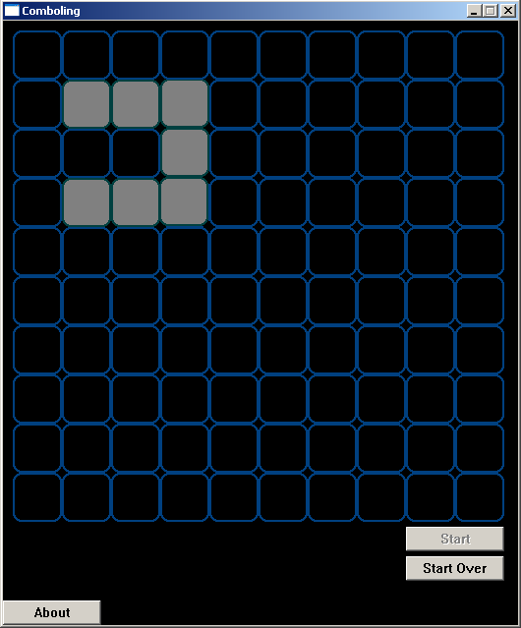
A trap waiting to happen

The reason I first disregarded this is because if the tile was made then I could still pick a tile in any direction of that tile and still come up with a puzzle that was solvable. The problem was consistent with a second problem that I encountered. With my very first method I created a random direction with a random range. The problem was back tracking that created unsolvable puzzles. The figure below will describe this. The tiles are numbered in their order of creation.
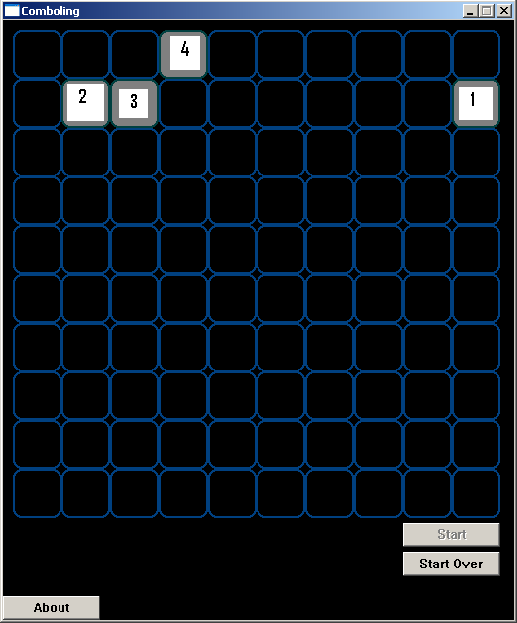
The problem is very clear and yet another problem is now created. The new problem is now the possibility that a tile will still be created along that path, therefore invalidating our numbering. We will disregard this for now and see what we come up with.
Two additions to our already made detection must be implemented. First, the direction from where our current tile was made and a “trap” detection. The direction that this new function will accept will be used to make sure we do not back track. This will eliminate the above scenario. The second will be “trap” detection. Once we have determined there is no collision between a tile and a selected blank space, we will check around the target for two tiles around that tile that are free. Why two? Remember that we now are restricted from backtracking and need another way out. This is an easily overlook part of this whole process. If there is one or less available tiles around our target tile then we will make like there is a collision and return true.
Now, back to what I disregarded and why. Well if you really take the time to look at the field and how the tiles are related in this game. If we were to place a tile on a path then it would still produce a solvable puzzle for the reason that there are routing tiles to create other possible solutions. I disregarded this kind of detection because at later levels in the game the possibility of having to re-create a field over and over again would have become quite prominent enough to slow the game to very troublesome speeds.
The consequence of this will be that I will not be able to display a solution to a puzzle. Now, how does this help you out? Well if you enlarge the scale of this and apply object collision detection then you get a very nice starting point for something extremely useful. Avoiding the need to backtrack and avoid “traps” is a key feature involved in chasing. Modifying this code to return a distance and point to where something should travel would help in creating something such as a rat running away from a cat.
Several variations can be made from this basic overview of collision detection and hopefully this will save some time for somebody wracking their mind over this highly underestimated code.

